Thursday 12th February

Dear Parents and carers

As we approach the end of the first half of the Spring term, I would like to share some of the special in-school events taking place next half-term. These occasions are always a wonderful opportunity to come together as a school community, and we hope that many of you will be able to join us and celebrate alongside the children.

World Book Day – Thursday 5th March:
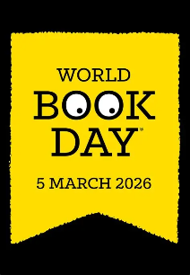
We will be taking part in this annual celebration giving everyone the chance to share a love of reading. On this day the children will be able to come to school dressed up as a book character of their choice with prizes given to the best dressed book character.

To celebrate this great day all the classes will be taking part in a range of reading activities throughout the day. These will include, creating a whole school story, adults sharing their favourite stories with classes and taking part in a variety of creative book character activities.

STEM (Science, Technology and Engineering) Afternoon – Tuesday 10th March:
Families are invited to join us in school for the afternoon to celebrate all things STEM related during National Science week.
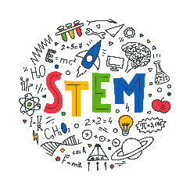
The afternoon will begin with a special assembly at 1.20pm followed by exciting and engaging STEM activities in each of our classes. We hope many of you will be able to join your children for this wonderful event.

Finally can we wish all of our families a restful and relaxing half-term break and we look forward to welcoming you back to school on Monday 23rd February.

Best wishes

Nicky Tyler
Head of school

